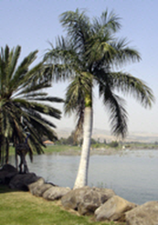
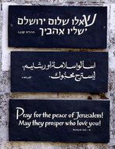
The Life & World of Jesus
A Shoresh Study Tours Itinerary
5 to 15 March, 2020
Hosted by: Alison Marchant and Rachel Meakin

We will trace the life of Jesus from his home in Galilee to Jerusalem, giving particular attention to the First Century Jewish context in which Jesus lived. Our goal is a greater understanding of Jesus' ministry and the application of His teachings for us today.

Day 1 Thursday, 5 March, 2020
ARRIVAL IN THE LAND OF PROMISE
We arrive at Ben Gurion Airport near Tel Aviv, where we will be met by our guide and bus driver for the trip. From the airport we travel to our hotel on the Mediterranean Coast. Overnight: Seasons Hotel, Netanya, Mediterranean Coast

Day 2 Friday, 6 March, 2020
LIGHT TO THE NATIONS – Jews, Gentiles, and the Messiah
Today we travel north up the coast and then inland to the Galilee, visiting a number of Biblical sites that testify to God’s faithfulness to His word, past, present, and future. We begin our day at the remarkable ruins of the Herodian city of Caesarea Maritima, the site of the conversion of Cornelius and the location from which Paul left the shores of Israel and set sail on his journey to Rome. We then travel up the coast to Mount Carmel, with a spectacular view over the North of Israel, near the spot where Elijah confronted the prophets of Baal. Time permitting, we will continue along the route of the ancient Via Maris to Megiddo, one of King Solomon’s cities, and according to the Book of Revelation possibly the assembly point for the armies marching to the battle of Armageddon. We conclude our day at Nazareth, Jesus’ boyhood home and place of His early ministry, plus a visit to the “Nazareth Village,” a project run by local believers. Overnight: Kinar Hotel, Sea of Galilee

Day 3 Saturday, 7 March, 2020
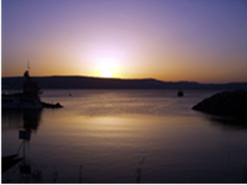
AROUND THE SEA OF GALILEE – Daily Life and Religion in the Time of Jesus
Our day will be spent visiting various sites around the Sea of Galilee as we try to picture daily life and religion in the First Century, and seek to understand better the miracles and teachings of Jesus in His original Jewish context. We start the day at Chorazin, the well-preserved ruins of a typical Galilean village, where we study village life, Jewish religion, and the Pharisees. Our next stop will be the Mount of Beatitudes, traditional site of the Sermon on the Mount, where we consider the Kingdom of God in Jesus’ teachings. Then a short walk or drive down to the lakeside, to Capernaum, the town where Jesus lived during the majority of His ministry, and Tabgha, which commemorates Jesus meeting the disciples after the resurrection, and Peter’s restoration and recommissioning by Jesus. We will visit Kibbutz Ginosar to see the “Jesus Boat”, a Galilean fishing boat from the First Century, then take a boat ride on the Lake to enjoy the views and a time of worship and prayer. Our last stop of the day will be at Beit Bracha, CMJ’s beautiful prayer centre overlooking Lake Galilee where we will have a quiet time of reflection. After dinner we hope to meet with a local believer. Overnight: Kinar Hotel, Sea of Galilee

Day 4 Sunday, 8 March, 2020
NORTHERN ISRAEL – “Who Do Men Say That I Am?”
Today we explore Northern Israel, one of the most beautiful regions of the country, seeking to understand what the Jewish people of 2,000 years ago expected of the Messiah, and how that was fulfilled in Jesus. We will drive up to the magnificent Golan Heights and along the lower slopes of Mount Hermon – Israel’s highest mountain and the most likely site of the Transfiguration. Along the way we pass various Druze Villages. Stops will include Caesarea Philippi, in the region where Peter made his famous confession that Jesus is the Messiah, also Mt. Bental, a lookout spot near the border with Syria, and the area of the road to Damascus where the Apostle Paul met the Lord. We will also visit Kibbutz El Rom, one of Israel’s first kibbutzim in the Golan Heights. Our final stop is the Dan Nature Reserve. Here we see remarkable archaeological remains of the Old Testament city of Dan, including the city gate from the time of Abraham, and consider ancient Israel’s apostasy. During a beautiful walk by a tributary of the river Jordan we will discuss the meaning of “living water” in the Hebrew Scriptures and Jesus’ teaching. Overnight: Kinar Hotel, Sea of Galilee

Day 5 Monday, 9 March, 2020
THE JORDAN VALLEY – “In the World But Not of It”
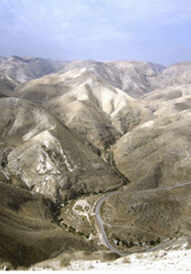
Today we leave the Galilee and journey south down the spectacular Syrian African Rift Valley to the Dead Sea in the arid Judean wilderness. We will consider the cultural tensions that existed at the time of Jesus, both between Greco-Roman culture and Jewish culture (and later the early church), and also between the Jewish religious establishment of the day and various spiritual reformers. At the Jordan River we will discuss the ministry of John the Baptist and his relationship with Jesus. Our next stop is the Biblical city of Beit Shean to explore the visually impressive excavations from its Roman-Byzantine period when it was one of the ten Hellenistic cities of the Decapolis. We also hope to visit the beautiful spring-fed pools at Sachne, near the base of Mt. Gilboa. From here we continue down the Jordan Valley, passing through the region of Jericho – the oldest and lowest city on earth. Our last visit of the day will be Qumran, the probable home of the Essenes, a First Century Jewish sect which may have influenced early Christianity, and the site of the most exciting archaeological discovery ever made in Israel – the Dead Sea Scrolls. Overnight: Ein Gedi Hotel, Dead Sea

Day 6 Tuesday, 10 March, 2020
THE JUDEAN DESERT - Seeking Refuge in the Wilderness
Our theme today is the wilderness and what it signified to the ancient Israelites. We begin at Masada, Herod the Great’s magnificent fortress palace in the desert and the last stand of the Zealots, a Jewish revolutionary group at the time of Jesus. From Masada we drive north to the beautiful subtropical oasis of Ein Gedi, where David hid from Saul. Depending on conditions, we can walk into the nature reserve and possibly to the waterfalls. We may see some wildlife, including rock badgers and ibex. We will also discuss the temptation of Jesus in the Wilderness. We finish our afternoon with the opportunity of a float in the therapeutic mineral-rich waters of the Dead Sea. At the end of the day we will make the steep ascent through the Judean hills to Jerusalem – the City of the Great King. Overnight: Christ Church Guest House, Jerusalem

Day 7 Wednesday, 11 March, 2020
JERUSALEM IN THE TIME OF JESUS – The Temple at the Center
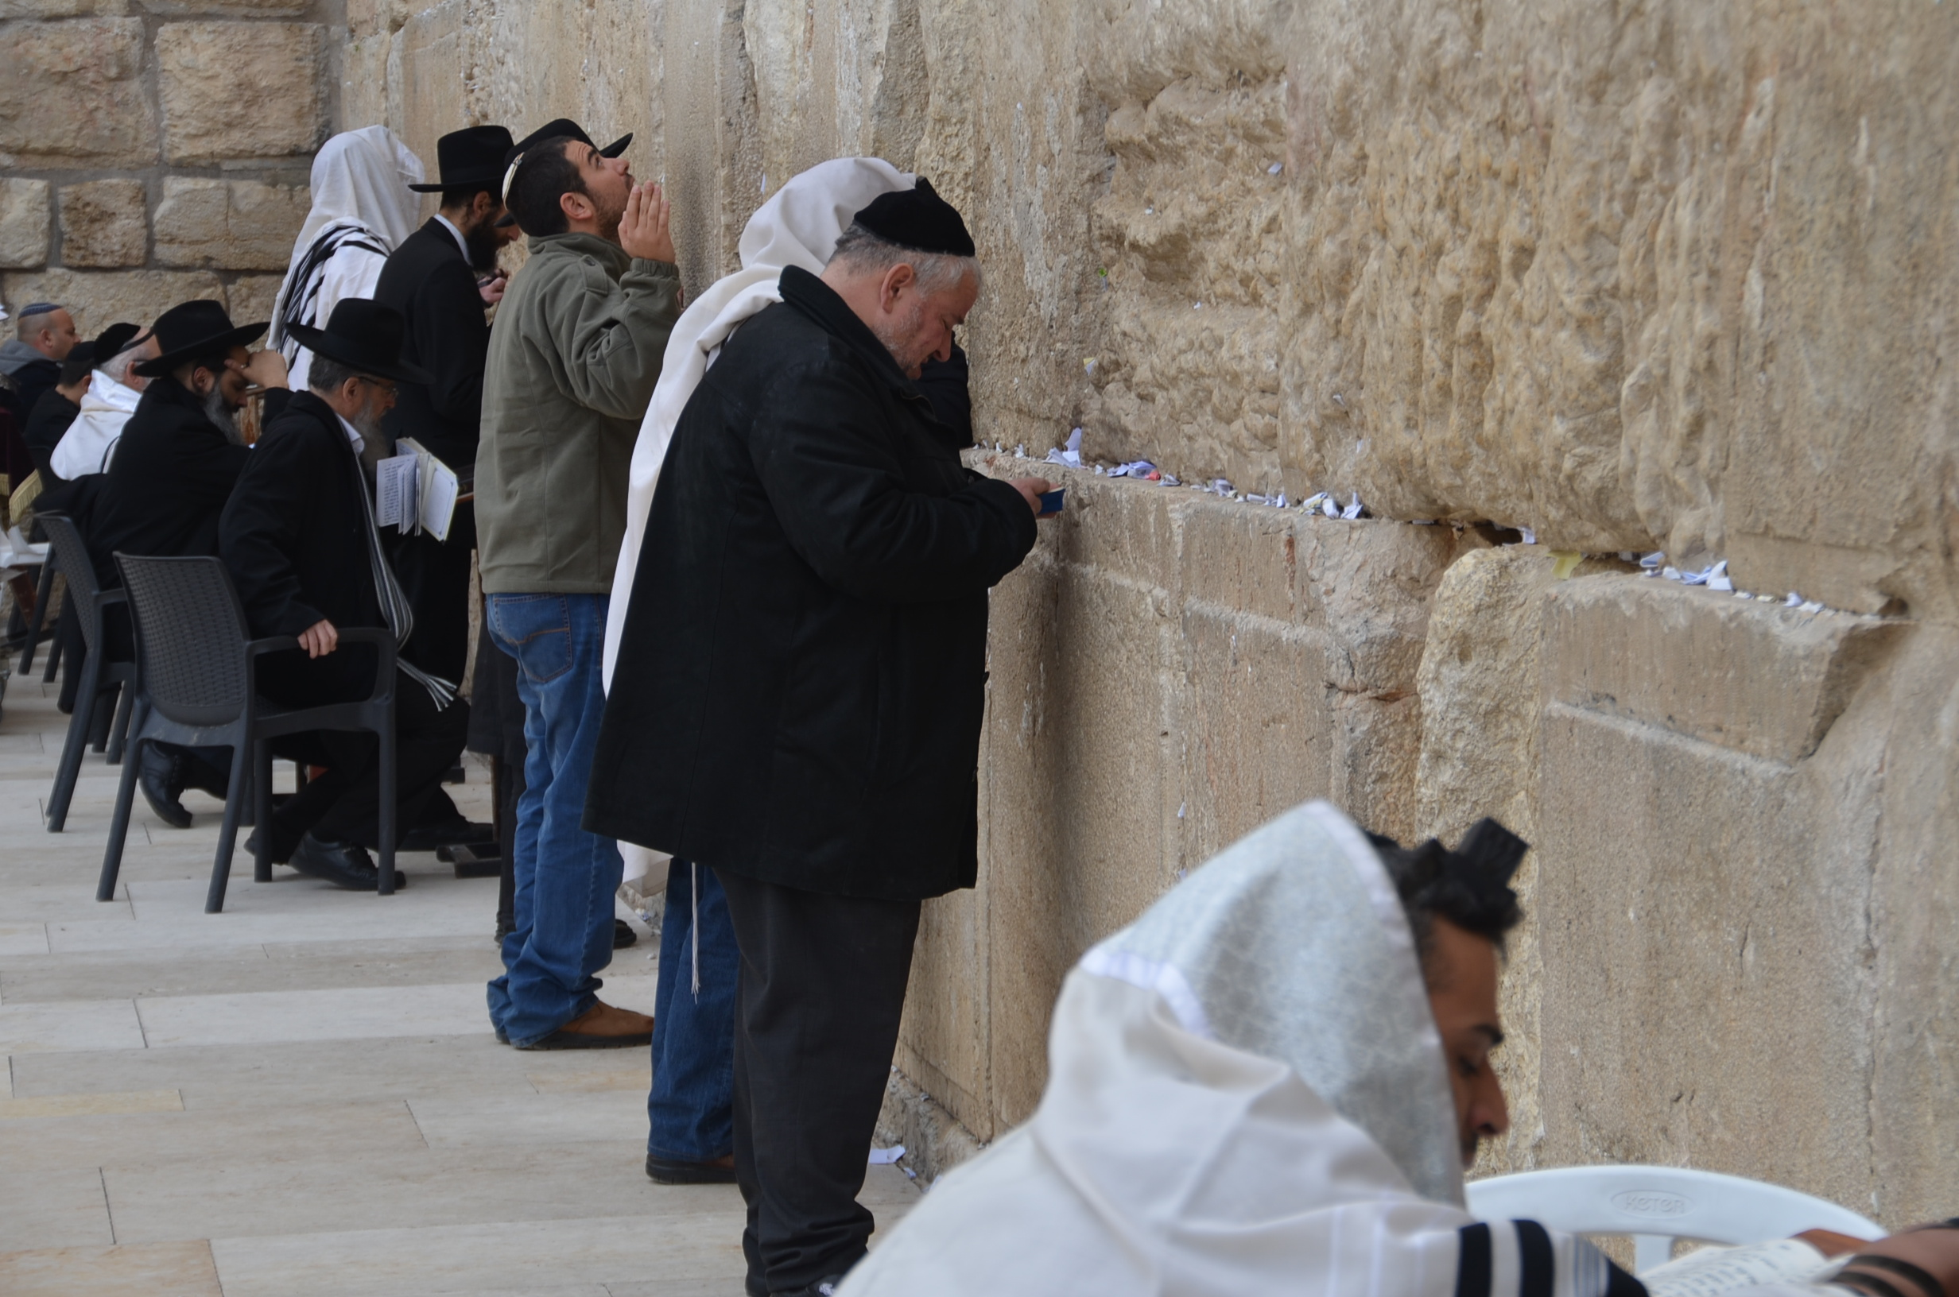
Today will be devoted to learning about Jerusalem in Jesus’ day, when the Temple in Jerusalem was the centre of Jewish life. We will discuss how worship was performed in the temple, the Sadducees and Jesus’ attitude towards them, and generally enrich our understanding of many important events in the gospels and book of Acts. An early start will take us up to the Temple Mount (conditions permitting), where we’ll consider some of Jesus’ activities there, as well as the claims of Islam. After a visit to the Western Wall place of prayer, Judaism’s most holy site, we enter the subterranean Western Wall Tunnels to walk at what was street level in the time of Jesus. Then we make our way through the Jewish Quarter of the Old City to see the Herodian Villas, the palatial mansions that were home to the Sadducees, the ruling Jewish political and religious group at the time of Jesus. We complete our day at the excavations near the base of the Temple Mount and discuss Pentecost on the Southern Steps where Jesus walked. Overnight: Christ Church Guest House, Jerusalem

Day 8 Thursday, 12 March, 2020
FREE DAY IN JERUSALEM
Today is free for rest, reflection, shopping in the old or new city, or for the energetic, perhaps a walk on the walls of Jerusalem. Shoresh will provide a list of interesting options for those who want to explore on their own. Before supper, we will visit the Christ Church Heritage Centre to learn about CMJ’s 200-year history of ministry among the Jewish people.
In the evening we will celebrate a shortened Jewish Passover Seder meal together, making Biblical connections with the role of the Lamb of God and the “last supper” which Jesus shared with his disciples. For many this is a real highlight of the tour. Overnight: Christ Church Guest House, Jerusalem

Day 9 Friday, 13 March, 2020
THE RESTORATION OF HOPE – A Garland Instead of Ashes
Today we consider both a great tragedy and the wonder of the Lord’s redemptive power. We will examine the systematic annihilation of six million Jews in the Nazi genocide, God coming to earth in the form of a man to save His people from their sins, and the loving witness of Christians committed to the Biblically prophesied physical restoration and spiritual rebirth of the Jewish people. After breakfast, we drive to Yad VaShem, the Israel Memorial Museum to the Holocaust, with an opportunity to examine the spiritual and theological roots of the most notorious genocide in history and the connection between the Church, Jesus and the Jewish people. From here we drive to Bethlehem, to visit the Church of the Nativity, marking the possible site of the birth of Jesus, and the “Shepherd’s Fields” remembering the angels heralding the advent of Messiah. In the evening another highlight could be to join our Jewish friends welcoming the Sabbath at the Western Wall. Overnight: Christ Church Guest House, Jerusalem

Day 10 Saturday, 14 March 2020
IN THE STEPS OF JESUS – Crucifixion, Death, Burial and Resurrection
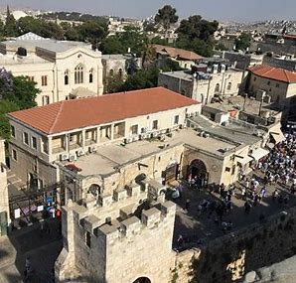
Today we focus on sites related to the Biblical passages concerning Jesus’ last week in Jerusalem. Our goal is to understand why He was crucified, how He was buried, and what it meant to the Jewish people of the First Century that He was raised from the dead. We begin our day with a panoramic overview of Jerusalem from the Mount of Olives, the site of Jesus’ ascension to heaven and His future second coming. After viewing a tomb from the time of Jesus, we walk down the Mount of Olives to traditional Gethsemane. Next, crossing the Kidron Valley, we enter the Old City through Lions Gate, stopping to examine the remains of the Pool of Bethesda. From here we walk to the Church of the Holy Sepulchre, the most likely site of the burial and resurrection of Jesus, ending our tour with a time of reflection at a site that wonderfully illustrates Jesus’ burial and resurrection: the peaceful Garden Tomb. Overnight: Christ Church Guest House, Jerusalem

Day 11 Sunday, 15 March, 2020
TO THE ENDS OF THE EARTH – Christ Church, Jerusalem and our journey home
Our day starts with the opportunity to join the congregation of Christ Church, Jerusalem in their morning service. Christ Church was the first Protestant Church in the Middle East, strategically placed in the Old City, and is a very important part of the work of The Church’s Ministry among Jewish People. After a quick lunch, we drive to Tel Aviv airport for our journey “to the ends of the earth.”

IMPORTANT - PLEASE NOTE:
- Most days on this itinerary involve a regular amount of walking and/or climbing. Therefore this trip cannot generally accommodate those who have significant difficulty with climbing stairs or walking a half a mile at a time. Please be in contact with the trip leaders if you have any concerns about this.
- Itinerary and accommodation subject to change if conditions necessitate.
- It is mandatory for each participant to have travel insurance to cover medical costs or trip cancellations.

